DAADD Recommendations

- Add the amount of money the company has got from running a particular add. How many people bought that particular product they advertised. How much discounts was given out and how much discount has been used.
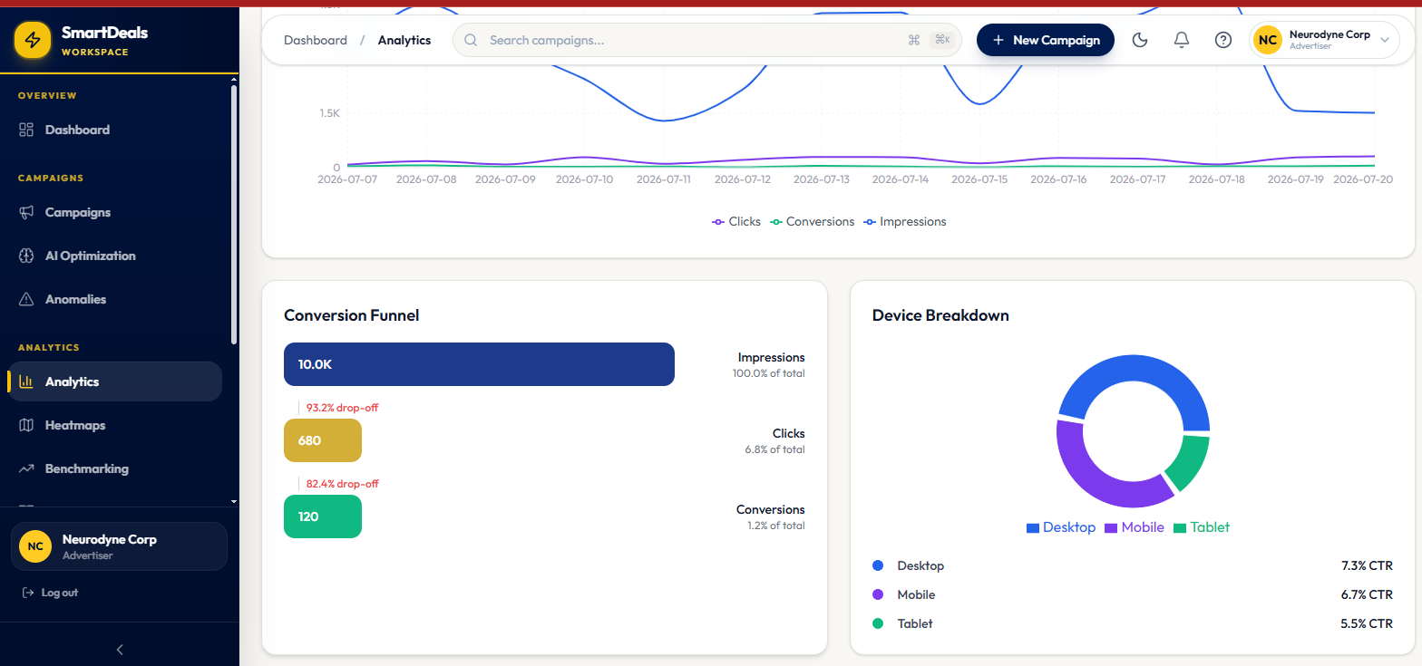

- I think this is really good except you have to add how much was spent on the add and how much profit has been made.
GOOD POINTS. SO WE WILL KNOW THEIR PROFIT WITHOUT THEM KNOWING THAT WE KNOW. WHAT DO YOU THINK? WE CAN SELL THOSE REPORTS AS A PREMIUM SERVICE
- 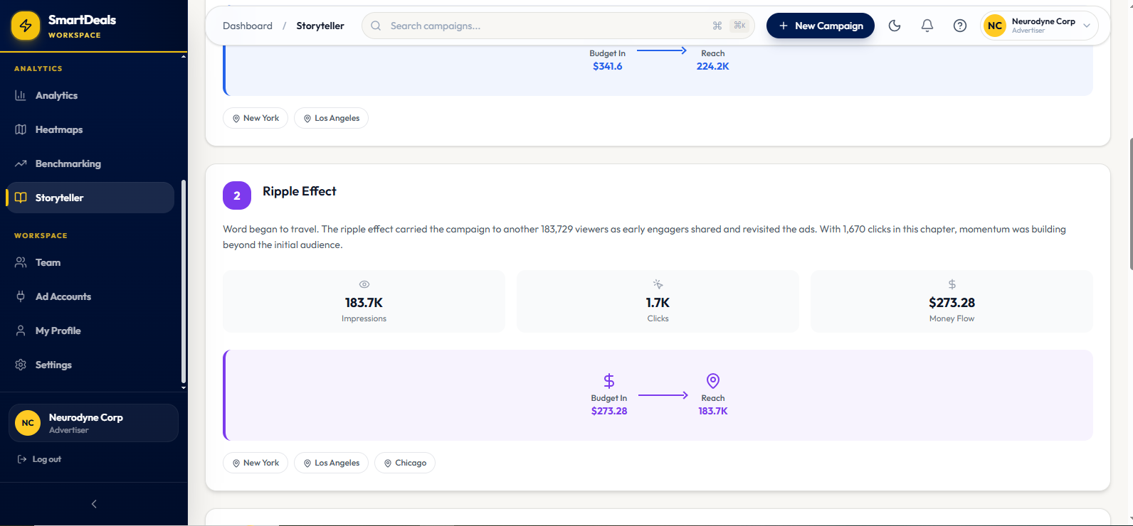

3. When I click support nothing happens.
SAME HERE

- The price you put here shouldn't be so. It depends on the percentage of discount we get and decide to share with the clients of that particular ad.
OK. AN EQUATION IS REQUIRED
- Also, you have to add the amount spent per a customer in that particular shop and then generate a qr code for the user to give the advertiser then the cashier at the advertisers end will have to enter it in the app together with the total spent by the customer then the discount will be applied if the qr code scanned is correct. Have you implemented this feature?
- A SINE-QUA-NON TO THE SUCCESS OF THIS APP. THIS IS BECAUSE AT THE BACK END, WE WILL BE CREATING AN E-LOYALTY SYSTEM AT THE SAME TIME BUILD BIG DATA FOR CONSUMER BEHAVIOUR. THE MONEY IS IN THE BEHAVIOURAL PATTERNS THAT WILL ENABLE US TO PREDICT CONSUMER BEHAVIOUR!😇
- The users should be given the chance to increase their tokens by keeping a streak board and a leadership board. So regular users of the app can get like a 0.5x increase in all their token anytime they are rewarded for iterating with the app.
- Also there should be a section to write your expectation upon visiting the place. You can upload a picture of the place and your experience there to earn more money or tokens. Rather afterwards you can rate the place or the service based on your experience. Does that make sense?
ITS A MUST!

YOU CAN ALSO MARK YOUR LOCATION ON MAPS WITHIN THE APP.

Version 2 review
- Add the details of the advertiser to the adverts. For instance location, promotion duration, and contact details. You barb?
SHARP
- You can add a chat box so clients can text companies on the platform about enquiries.
AND ALSO KINK TO ONLINE MARKET LACES CONNECTED TO THE ADVERTISER'S BUSINESS IF ANY…

Version 2 add ons:

- Chat box for end users to chat with advertisers.
- The token calculator that tells how much an interaction is. For instance $0.01 = 1 token
- VIP end users who will have their tokens increased because they frequently visit the advertisers outlet. It is free to become VIP. You just need to use the app frequently and also visit the outlets frequently. So we need to set the metrics for this.
- The end user will see the total token they can earn from one add. They can see how much they can earn per an interaction with an ad. They can calculate the token price using the token calculator.
- The advertiser exhausts the amount per an ad and its reach when the budget for the ad is exhausted.

Chat GPT input:

FonAd (Digital Adverts Analytics & Deals Dashboard – DAADD)

Version 2 Product Enhancement Requirements

Purpose
The following requirements expand the existing FonAd platform. These enhancements focus on improving campaign transparency, merchant redemption, customer engagement, advertiser communication, and business intelligence.
The objective is to create a platform that not only measures advertising performance but also tracks real-world business outcomes, customer satisfaction, and merchant conversions.

1. Enhanced Advertiser Analytics Dashboard
The advertiser dashboard should provide a comprehensive overview of campaign performance from both a marketing and financial perspective.
In addition to the current analytics, the dashboard should display:

Campaign Financial Performance
- Total campaign budget
- Amount spent from the campaign budget
- Remaining campaign budget
- Number of customers acquired through the campaign
- Number of successful merchant redemptions
- Total sales generated through the campaign
- Total value of discounts issued
- Total value of discounts redeemed
- Total revenue generated from customers who redeemed campaign rewards
- Estimated profit generated from the campaign
- Return on Advertising Spend (ROAS)
- Return on Investment (ROI)
The dashboard should enable advertisers to clearly understand whether their advertising investment is generating profitable business outcomes.

2. Merchant Redemption Process
The redemption process should be redesigned to ensure greater security, transparency, and accurate transaction tracking.

Customer Flow
When visiting a participating merchant:
- The customer selects the merchant outlet in the FonAd app.
- The customer enters the total purchase amount (optional if the merchant will enter it).
- The customer chooses how many tokens they wish to redeem.
- The application generates a secure, one-time QR code that expires after a short period (for example, two minutes).

Merchant Flow
After scanning the QR code, the merchant's system should:
- Validate the QR code.
- Confirm that the customer has sufficient tokens.
- Display the number of tokens selected for redemption.
- Allow the cashier to enter the purchase details, including:
  - Items purchased
  - Quantity
  - Total purchase amount
- Automatically calculate the applicable discount.
- Display:
  - Original bill
  - Discount applied
  - Final amount payable
- Complete the transaction and deduct the redeemed tokens from the customer's wallet.
Each redemption should generate a digital receipt for both the customer and the merchant.

3. Customer Spending Analytics
The system should maintain purchase history for every customer.
This includes:
- Merchant visited
- Outlet location
- Purchase amount
- Discount received
- Tokens redeemed
- Date and time
- Products purchased (where available)
This information will support future analytics, personalized recommendations, and customer loyalty features.

4. Support Centre
The current Support option is non-functional.
It should be implemented with the following features:
- Frequently Asked Questions (FAQ)
- Contact Support
- Live Chat (optional)
- Email Support
- Report a Problem
- Report Fraud or Abuse
- Campaign Assistance
- Merchant Assistance

5. Dynamic Reward Allocation
Reward values should not be fixed.
Instead, rewards should be dynamically calculated based on the advertiser's campaign configuration.
Each campaign should allow advertisers to configure:
- Campaign budget
- Total discount percentage offered
- Percentage of the discount shared with consumers
- Maximum tokens available for the campaign
- Reward per interaction
For example:
- Merchant offers a 20% promotional discount.
- FonAd and the merchant agree that 5% of that discount will be shared with consumers as reward tokens.
- The reward calculation should be based on this configuration rather than using fixed reward values.
This gives advertisers greater flexibility while ensuring campaign costs remain controlled.

6. Token Calculator
Consumers should have access to a Token Calculator that clearly explains how rewards are earned.
The calculator should display:
- Current token value
- Reward conversion rate
Example:
- $0.01 = 1 Token
Users should be able to estimate:
- How many tokens they can earn from viewing an advert.
- How many tokens they can earn by clicking an advert.
- How many tokens they can earn by completing reviews.
- How many tokens they can earn by uploading photos.
- The estimated value of their accumulated tokens.
This improves transparency and encourages user engagement.

7. Campaign Budget Exhaustion
Campaigns should automatically stop distributing rewards once their allocated reward budget has been exhausted.
The system should:
- Track campaign spending in real time.
- Monitor remaining reward allocation.
- Pause campaigns automatically when funds are depleted.
- Notify advertisers before budgets are exhausted.
- Allow advertisers to top up campaign budgets.

8. Customer Loyalty System
Introduce a loyalty system that rewards consistent users.

Streak Rewards
Users should earn streak bonuses for consecutive activity.
Examples include:
- Daily app usage
- Consecutive advert interactions
- Consecutive merchant visits
- Consecutive review submissions
Longer streaks should result in higher token multipliers.

Leaderboards
Create public leaderboards that encourage engagement.
Possible leaderboards include:
- Most Active User
- Most Reviews Submitted
- Most Merchant Visits
- Highest Token Earner
- Longest Activity Streak
Leaderboards should reset periodically (weekly and monthly).

VIP Membership
Introduce a free VIP tier for highly engaged users.
Users qualify automatically based on activity metrics such as:
- Number of merchant visits
- Number of successful purchases
- Frequency of app usage
- Number of verified reviews
- Total engagement score
VIP members receive benefits such as:
- Higher token multipliers
- Exclusive campaigns
- Early access to promotions
- Bonus rewards
- Special badges
The qualification criteria should be configurable by administrators.

9. Enhanced Customer Experience Reviews
Before visiting a merchant, users should be encouraged to record their expectations.
After visiting, users can compare their expectations with their actual experience.

Before Visit
Users can provide:
- Expected experience
- Expected service quality
- Expected product quality
- Planned purchase

After Visit
Users should be able to submit:
- Reality rating
- Overall satisfaction
- Product rating
- Service rating
- Written review
- Photos
- Videos (optional)
Uploading photos or videos should earn additional reward tokens, subject to moderation and verification.
This creates a richer and more authentic review ecosystem.

10. Advertiser Information
Each advert should display sufficient business information to help consumers make informed decisions.
This should include:
- Business name
- Business logo
- Physical location
- Branch locations
- Contact number
- Email address
- Website
- Promotion duration
- Opening hours
- Business category
Users should be able to view this information directly from the advert page.

11. Customer–Advertiser Messaging
Implement an in-app messaging system that allows customers to communicate directly with advertisers.
Possible use cases include:
- Product enquiries
- Booking requests
- Promotion enquiries
- Customer support
- Order confirmation
Messaging should support:
- Text messages
- Image attachments
- Read receipts
- Notifications
- Conversation history
Advertisers should manage conversations from their dashboard.

12. Advertisement Reward Information
Each advert should clearly display:
- Maximum tokens available from that campaign
- Tokens earned per impression
- Tokens earned per click
- Tokens earned per review
- Tokens earned for uploading photos or videos
- Remaining campaign reward budget (optional)
Consumers should know exactly what they can earn before engaging with an advert.

13. Merchant Performance Dashboard
Merchants should have their own analytics dashboard showing:
- Number of customer visits from FonAd
- Number of QR code redemptions
- Revenue generated through FonAd
- Total discounts given
- Total discounts redeemed
- Average customer spending
- Average discount per customer
- Repeat customer rate
- Customer satisfaction ratings
This enables merchants to evaluate the business value generated by the platform.

14. Platform Vision
FonAd should evolve beyond a traditional advertising platform into a complete advertising intelligence and customer engagement ecosystem.
The platform should enable advertisers to understand:
- How many people saw an advert.
- How many interacted with it.
- How many visited a merchant.
- How much customers spent.
- How much revenue was generated.
- How much profit resulted from the campaign.
- How customers rated their experience.
- Whether the advert accurately represented the product or service.
At the same time, consumers should be rewarded for genuine engagement, while merchants benefit from measurable customer acquisition and increased sales.
The long-term vision is to make advertising transparent, measurable, rewarding, and directly connected to real-world commercial outcomes.

1. Enhanced Advertiser Analytics Dashboard
The advertiser dashboard should provide a complete overview of campaign performance from both an advertising and business perspective.
In addition to the current analytics, the dashboard should display:

Campaign Financial Performance
- Total advertising budget
- Amount spent from the campaign budget
- Remaining campaign budget
- Revenue generated from customers who redeemed campaign rewards
- Estimated profit generated from the campaign
- Return on Advertising

